Title of the Article

Name of the author, e.g. John Smith
Abstract
Text of the abstract.
Recommended extent is 100-150 words. Abstract is not divided into paragraphs and does not include citations. It should include objective, methods, results, and conclusion.
Keywords
4 – 6 keywords.

I. Introduction
Text of the introduction, including motivation, originality etc.

II. Main text
The extent of the entire paper should not exceed 15 pages. Please, use footnotes for citations, e.g. , or cite the literature directly in the text, e.g. “…as mentioned by Becker (1993)”.
All equations should be numbered using parentheses, e.g. (1). Tables and figures should have the following format in greyscale only.
Please, do not use any spacing between paragraphs, tabulators, etc. that are not pre-defined.
Table 1 Rate of unemployment and inflation rate in the Czech Republic
 | 2005 | 2006 | 2007 | 2008 | 2009
Rate of unemployment (%) | 9,0 | 8,1 | 6,6 | 5,5 | 8,0
Inflation rate (%) | 1,9 | 2,5 | 2,8 | 6,3 | 1,0
Source: Czech Statistical Office (2010)
Figure 1 Rate of unemployment and inflation rate in the Czech Republic
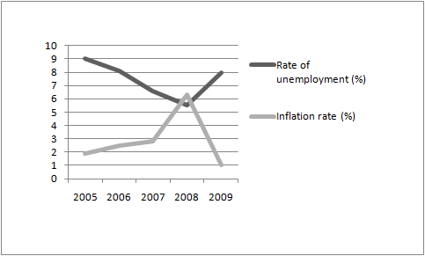
Source: Czech Statistical Office (2010)

III. Next chapter
All chapters, including the conclusion, should be numbered as shown above using Roman numerals.

IV. Conclusion
Text of the conclusion.
Acknowledgements
Text of the acknowledgements (if any).
References
Please, use the following patterns for references (APA Citation Style). All mentioned references must be cited in the text/footnotes and vice versa.
Journal Article
Author (Year). Article Title. Journal Title, vol.(no.), pages.
e.g. Coase, R. H. (1993). Law and Economics at Chicago. Journal of Law and Economics, 36(1), 239–254.
Book
Author (Year). Book Title (Edition). City of publication: Publisher.
e.g. Becker, G. S. (1993). Human Capital: a Theoretical and Empirical Analysis with Special Reference to Education (3rd ed). Chicago: University of Chicago Press.
Chapter in a Book
Author (Year). Chapter Title. In Editor (ed.). Book Title (Edition). City of Publication: Publisher.
e.g. Holmes, S. (1988). Precommitment and the Paradox of Democracy. In Elster, R.; Slagstad, R. (eds.). Constitutionalism and Democracy (1st ed). Cambridge: Cambridge University Press.
Web Site
Publisher/Company. (Year accessed). Web Site Title. Retrieved “date” from “URL”.
e.g. Czech Statistical Office (2010). Czech Republic: Key Macroeconomic Indicators. Retrieved December 12, 2010, from http://www.czso.cz/eng/redakce.nsf/i/macroeconomic_indicators/$File/AHLMAKRO.xls
Appendix
All appendices should be numbered using caps, e.g. Table A.

The affiliation (including full address) and e-mail of the author(s), e.g. University of Vienna, Universitätsring 1, 1010 Vienna, Austria. E-mail: JohnSmith@email.eu.
Becker (1993).

